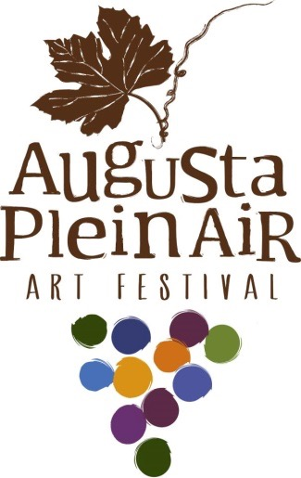Registration may be made by mail, phone or online in advance or you may register at the time of your arrival at the Festival. For advance registration, please complete the form below and mail with your check for $100 plus applicable registration fee(s) for Workshop(s), Private Estate, and Screen Rental if selected. If you are reserving a booth space for the final sale, please check below. Make your check payable to Greater Augusta Chamber of Commerce or GACC. If you wish to make payment by credit card please phone 636-228-4005.
2020 Augusta Plein Air Festival
Artist Registration Form

REGISTER ON-LINE AT: https://www.augustapleinair.com/artist-registration/

Augusta Plein Air
P.O. Box 41
Augusta, MO 63332
636-228-4005

Name ________________________________________________________________________________
Address ______________________________________________________________________________
City _________________________________________State. ____________________ Zip ____________
Telephone (home) ______________________________(cell). __________________________________
E-maiL ______________________________________website ___________________________________
Circle T-shirt size (complementary): S M L XL 1XL 2XL 3XL
Screen Rental: $15.00 per panel. Number of panels needed. __________
Special Events:
Private Estate #1: Tuesday, April 28, 2018 at 7:00am: $15.00
First 30 artists to register will be eligible to paint at this private location, after the 30 slots are filled you will be placed on a waiting list. As in years past some artists that sign up decide not to participate. Get your registration in early to reserve your space or spot on waiting list. Would you like to participate?

Please circle: YES NO
Workshops: Check Workshop(s) you are registering for below.
- Plein Air Without Brushes – Oil/Acrylic – Wednesday April 22nd & Thursday April 23rd with Marty Coulter -- 9am to 4:30 pm; Lunch provided.
  - One Day:
  - April 22nd Only - $85 [Limit 12 Students]
  - April 23rd - $85 [Limit 12 Students]

  - Two Day: April 22nd and April 23rd - $150 [Limit 12 Students]
- Landscape Painting – Oil/Acrylic – April 24th/25th/26th (Friday/Saturday/Sunday) with Billy O’Donnell – 9am to 4pm; Lunch provided - $375 [Limit 12 Students]
- Plein Air Tips and Tricks – All Mediums – Monday April 27th with Gabriele Baber – 9am to 4pm; Lunch provided - $85 [Limit 12 Students]
- The Forest or the Tree – All Mediums – Tuesday April 28th with Jane Mudd – 9am to 4pm; Lunch provided - $85 [Limit 12 Students]
- The Human Touch – All Mediums – Wednesday April 29th with Henryk Ptasiewicz – 9am to 4pm; Lunch provided - $85 [Limit 12 Students]
Artist Host Family Housing List Request: For Artists that live more than 50 miles from Augusta, Missouri, several residents in Augusta have offered to host an Artist for the Augusta Plein Air Event. We will place Artists with Host Families based on date registered for the event. Being placed on the list does not guarantee that we will be able to place you with a Host Family. Deadline to request housing is April 1st, you will be notified not later than April 10th if you have been placed.
Please indicate:
- Yes

- No
  - I live less than 50 miles from Augusta, Missouri
  - I have a Host Family already arranged. Host Name: __________
  - I have arranged to stay at a Bed & Breakfast or Hotel.

- Request a place to park an RV
Permission:
YES or NO: You may use photos taken during the Augusta Plein Air Festival on the website, Facebook and other advertising materials.
YES or NO: You have permission to share my email with our Marketing Agency.
Register for a Booth at the Final Sale:
You may reserve your final sale booth space at the same time that your register for the Plein Air Art Festival. The Final Sale will be hosted by Mount Pleasant Estates, see attached layout. We will have space available in the Terrace Ballroom 1-69, in the Entrance Tasting Room (A- J) and a large number of outdoor spaces (you will need to bring your own tent if weather is inclement). Please indicate your first three choices for booth location. You will be contacted directly with confirmation of your assigned space. Spaces will be assigned in the same order that your registration form is received; on the off chance that all three of your choices are taken someone will contact you to let you know which spaces are still available.
Direct any questions to augustapleinair@gmail.com or to committee members: Chairman – Lynn Buccheit: 314-239-3988, Committee Members: Corinne Post: 314-580-2180, JoAnn Milster 636-248-5790, Kathleen Turner: 636-228-4005

Note: Refunds will be honored up to April 1, 2020

Artist Booth Layout for Final Sale a Booth at the Final Sale:

Artist Booth Layout for Final Sale
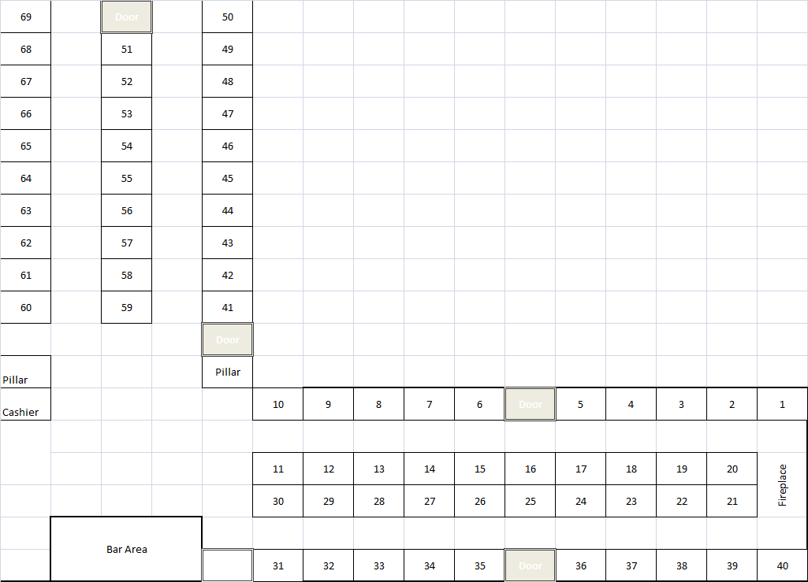

Layout of Mount Pleasant Tasting Room Booth Space
